Monte Carlo simulation

End-sem report

Yash Vanjani

(140123046)

Question 1

Following bivariate random variables (X,Y) are obtained from all possible combinitions of given standard normal variates:

For Z_1 = 0.9597 and Z_2 = -1.3404

X = 4.8388 , Y = -3.162954

For Z_1 = 0.9597 and Z_2 = 1.2238

X = 4.8388 , Y = 7.081017

For Z_1 = 0.9597 and Z_2 = 0.2551

X = 4.8388 , Y = 3.211064

For Z_1 = -1.3404 and Z_2 = 0.9597

X = -4.3616 , Y = 5.565918

For Z_1 = -1.3404 and Z_2 = 1.2238

X = -4.3616 , Y = 6.620997

For Z_1 = -1.3404 and Z_2 = 0.2551

X = -4.3616 , Y = 2.751044

For Z_1 = 1.2238 and Z_2 = 0.9597

X = 5.8952 , Y = 6.078758

For Z_1 = 1.2238 and Z_2 = -1.3404

X = 5.8952 , Y = -3.110134

For Z_1 = 1.2238 and Z_2 = 0.2551

X = 5.8952 , Y = 3.263884

For Z_1 = 0.2551 and Z_2 = 0.9597

X = 2.0204 , Y = 5.885018

For Z_1 = 0.2551 and Z_2 = -1.3404

X = 2.0204 , Y = -3.303874

For Z_1 = 0.2551 and Z_2 = 1.2238

X = 2.0204 , Y = 6.940097

Question 2

Sample mean obtained for sample size 200 = -0.3241586

Sample Variance obtained for sample size 200 = 7.353186

A large variance is observed for only 200 samples.

Variance reduces as sample size is increased

Sample mean obtained for sample size 200000 = -0.3241586

Sample Variance obtained for sample size 200000 =

Question 3

Following outputs are found:

For n=100

Using Naive Monte Carlo:

Estimate of the integral is = 0.58

Variance = 0.2425251

Using Anithletic variates:

Estimate of the integral is = 0.65

Variance = 0.1031107

Percentage variance reduction = 56.30866

Using Control variates:

Estimate of the integral is = 0.76

Variance = 0.1786065

Percentage variance reduction = 0.3529411

For n=1000

Using Naive Monte Carlo:

Estimate of the integral is = 0.681

Variance = 0.1883295

Using Anithletic variates:

Estimate of the integral is = 0.695

Variance = 0.08784917

Percentage variance reduction = 51.92008

Using Control variates:

Estimate of the integral is = 0.693

Variance = 0.2011537

Percentage variance reduction = 0.002714776

For n=10000

Using Naive Monte Carlo:

Estimate of the integral is = 0.6912

Variance = 0.1812871

Using Anithletic variates:

Estimate of the integral is = 0.6858

Variance = 0.09034357

Percentage variance reduction = 50.35888

Using Control variates:

Estimate of the integral is = 0.6909

Variance = 0.1852107

Percentage variance reduction = 0.0007828613

Observations:

1. Using Anithletic variates nearly 50% variance reduction is obtained.

2. Control Variates works very poorly in this case for all values of n as Y given is very similiar to the given raqndom variable (by taking integral transformation from hint).

3. As n increases, variance decreases so percentage variance reduction also decreases.

Question 4

Following Normal distributions are obtained by using Box-Muller method:

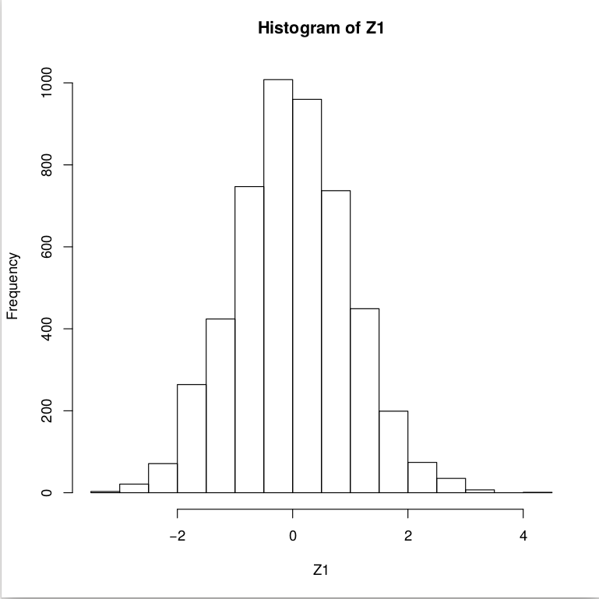

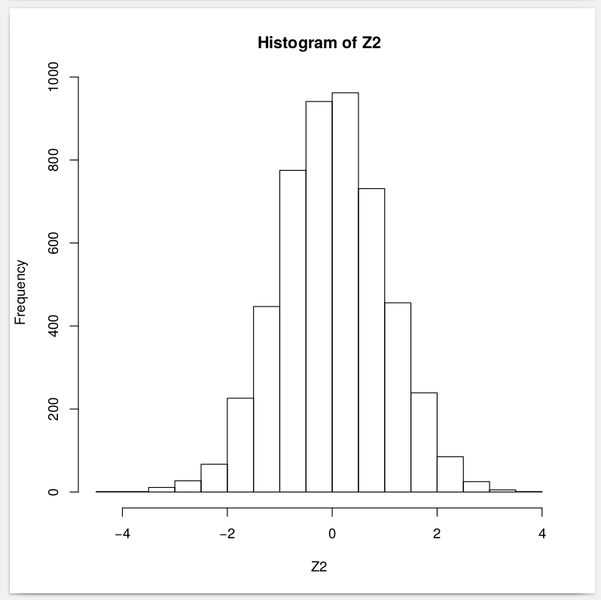

Output for GBM:

Mean of S(5) = 265.0601

Variance of S(5) = 0.0002210445

10 paths for GBM with given parameters:

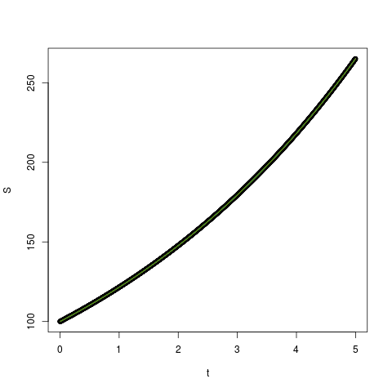

GBM obatined by changing mu =0.005 :

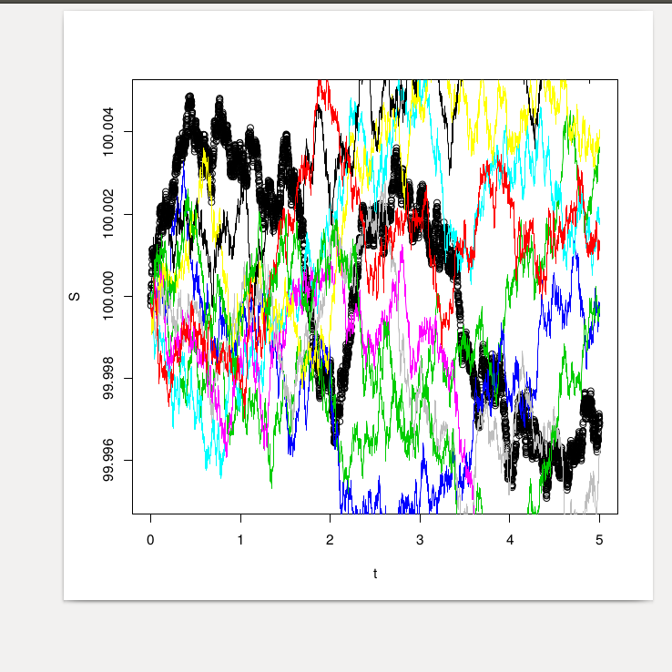

Because of very high value of mu given in question all GBM are very overlapping.